The Aurora Australis event on May 11th, was part of a larger, intense geomagnetic storm, classified as a G5 or "extreme" storm, which provided an exceptional opportunity to witness the southern lights across many parts of Australia.
On Flinders Island, the clear-ish skies and minimal light pollution made it an ideal spot for viewing this spectacular natural light show. This event was notable because such powerful solar activity had not been observed since 2003, making it a rare and memorable experience for those lucky enough to see it! It was wonderful to see so many people out enjoying this event and sharing their photos on social media.
Whitemark is facing the strong possibility of soon entering Stage 2 water restrictions as dry conditions continue to impact water levels at Henderson Dam. TasWater asks that residents please continue to reduce your non-essential water use – the TasWater website has some great tips if you need them.
In response to safety concerns, Council has introduced a new appointment system for certain categories of hard waste disposal (cars, motorbikes, machinery, caravans, trailers, and boats). This change aims to enhance safety and supervision at the facility, following a recent incident in which a community member was injured. This incident was not the first of its kind, underscoring the necessity of monitored access to the area. General hard-waste can still be put in the skip bin opposite the giving shed. This has been the process for the last few years.
As a Council-operated facility, Whitemark Tip must adhere to legislative and insurance requirements regarding public access. The new appointment system ensures that waste staff can manage and supervise the area effectively, addressing the challenges posed by their limited availability to provide on-demand access.
Whitemark does not currently impose a fee for hard waste disposal, allowing residents to dispose of items at no cost. However, if the community expresses a desire for greater accessibility or additional disposal options, it might be necessary to explore the possibility of introducing a fee to accommodate these enhancements and manage the associated costs effectively.
Unfortunately, the changing world does not allow us to do things the way we have always done so in the past.
A reminder that the Annual Community Survey is closing on the 7th June. The Flinders Boating Special Committee is also seeking feedback on their proposed plans to construct a second boat ramp at Whitemark, as well as extending the current jetty by 6 metres. These can be submitted electronically via Council’s website, or hard-copies are available at reception.
Lastly, there are a few grant opportunities currently open to community members, groups and not-for-profits. Council’s own Community Grant and the Gunns Bequest both close early June. TasNetworks is also offering grants of up to $10,000 for community groups and not-for-profits to deliver projects in the community which seek to positively impact on rising cost-of-living pressures and/or enhancing community resilience.
Rachel Summers - Mayor
P. 0467 046 809
E. rachel.summers@flinders.tas.gov.au
ORDINARY COUNCIL MEETING
Notice is hereby given that the next Ordinary Meeting of Flinders Council will be held at the Flinders Arts and Entertainment Centre, Whitemark on:
Wednesday 26 June 2024 commencing at 1pm.
Public Question Time will be held between 1:00 – 1:30pm. Members of the public are invited to attend.
The Agenda will be available for perusal from Friday 21 June 2024 on the Council Website www.flinders.tas.gov.au and at the Council Office.
Warren Groves
General Manager

Position Vacant
Safety Officer

Would you like to combine a rewarding career with a relaxed rural lifestyle in a friendly community environment?

Flinders Council is seeking a suitably qualified, experienced Safety Officer to join our team. The desired applicant will have a WHS qualification or be willing to undertake approved training to gain appropriate certification.

The position will be permanent part-time (52.5 hours per fortnight, negotiable) and duties will include assisting the Works and Services Coordinator in shaping our safe and compliant work environment.

A full description of this position can be viewed on Council’s website at: www.flinders.tas.gov.au/employment-and-business-opportunities

Please forward your resume along with an application addressing the key selection criteria in the position description to:

Att: Corporate Services Coordinator
Flinders Council
PO Box 40
WHITEMARK TAS 7255

Or via email to hr@flinders.tas.gov.au

The position description is available on Council’s website www.flinders.tas.gov.au or by phoning reception on 6359 5001.

Applications will be accepted until a suitable candidate is found.

Warren Groves
GENERAL MANAGER
Position Vacant
Roads Supervisor

Flinders Council is currently seeking an experienced Roads Supervisor to join our team. Reporting to the Works and Services Coordinator, the successful candidate will play a pivotal role in overseeing the maintenance, construction, and improvement of our island's roads infrastructure.
This newly created position presents a unique opportunity to contribute to the development of our community while enjoying the unmatched beauty and tranquillity of Flinders Island.
If you possess the required skills and experience and are passionate about making a positive impact on our island community, we encourage you to apply for this exciting opportunity.
This is a full-time, permanent role, the salary offered is subject to negotiation and dependent upon qualifications and experience.

A full description of this position can be viewed on Council’s website at: www.flinders.tas.gov.au/employment-and-business-opportunities

Please forward your resume along with an application addressing the key selection criteria in the position description to:

Att: Corporate Services Coordinator
Flinders Council
PO Box 40
WHITEMARK TAS 7255

Or via email to hr@flinders.tas.gov.au

The position description is available on Council’s website www.flinders.tas.gov.au or by phoning reception on 6359 5001.

Applications must be received by post on COB 7 June 2024.
Warren Groves
GENERAL MANAGER

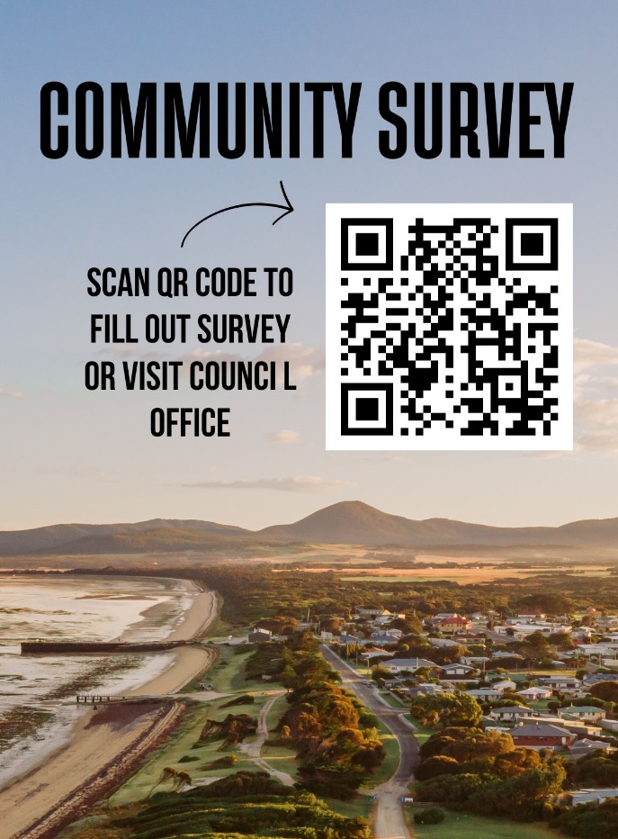
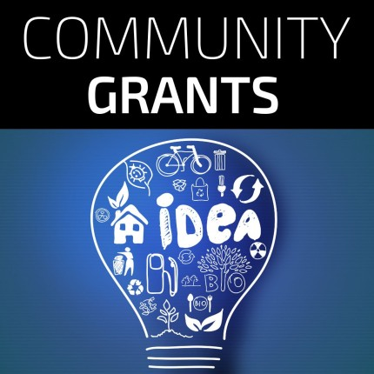
Community Grants & Gunn Bequest Program
NOW OPEN visit the Council website
This year, a total of $10,000 is available to assist community groups and individuals in fostering greater community connection, accessibility, and participation.
CALL FOR COMMITTEE REPRESENTATIVE
Nominations from the public are called for the position of Transport Sector Representative on the Furneaux Group Shipping Special Committee of Council.
The Committee consists of council and community representatives and exists to provide recommendations to Flinders Council on shipping matters, including port and associated infrastructure where it relates to shipping.
Nominations can be sent to:
Governance
Flinders Council
PO Box 40, Whitemark TAS 7255
Or via email to governance@flinders.tas.gov.au
The nomination period will remain open until Council receives sufficient nominations.
Rachel Summers
Chair | Furneaux Group Shipping Special Committee
Whitemark Tip – Opening Hours
- Monday 1.30pm - 4.30pm
- Tuesday 7am -10am
- Friday 1.30pm - 4.30pm
- Wednesday 8.30am - 11.30am
- Thursday 7am -10am
- Saturday CLOSED
- Sunday 1.30pm - 4.30pm
- CLOSED PUBLIC HOLIDAYS

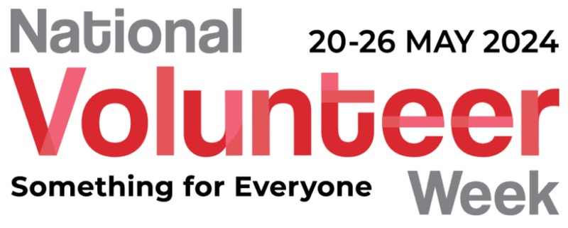
May 20-26, 2024 is National Volunteer Week; it’s a heartfelt opportunity to shine a light on the spirit and dedication of our volunteers here on the Furneaux Islands. This year’s theme, ‘Something for Everyone,’ perfectly captures the essence of our vibrant volunteer community, showcasing the diverse talents and boundless enthusiasm that each person brings to the table.
Volunteering in the Flinders Municipality means more than just giving time; it's about sharing your unique skills, passions, and kindness to foster a thriving community. From preserving our landscapes to enhancing our cultural events, every volunteer plays a pivotal role in weaving the vibrant tapestry of our island communities.
So, let’s celebrate the incredible impact of our volunteers. Whether you're nurturing the arts, participating in community support through organisations like the Community Shed, Lions Club, Hospital Auxiliary, Show Society, and the CWA; engaging in historical preservation, leading environmental initiatives, contributing to wildlife conservation, working in the health and wellbeing space, the sporting arena, or the business sector, or serving with the SES, TasFire, or as a Volunteer Ambulance Officer, there truly is a place for everyone to contribute. Each effort, no matter how small, drives significant change and embodies the true spirit of the Furneaux Islands.
To those of you already volunteering, thank you for your dedication and inspiring commitment. And to those considering joining our wonderful community of changemakers, this is a perfect time. Discover an area that ignites your passion and dive in—there’s something here for everyone.
Let's embrace this week to connect, share our stories, and celebrate the transformative impact we achieve together.
Here’s to making a difference, one volunteer at a time!

