I am so glad that winter is almost upon us, bringing in my favourite season here on the island! The days are refreshing and clear, painted with stunning sunsets, flowing seamlessly into enchanting starlit nights.

However, it's disheartening to share that our late-autumn tranquility has been marred by some incidents of vandalism. It seems some individuals have been tossing multiple cans of soft drinks at the walls of the hall and the nearby public toilets. While it might not appear to be a significant problem at first glance, it can result in damage and requires extra time for cleaning, which unfortunately means these facilities aren't readily available for our community members. There have also been instances of graffiti on the walls of the FAEC, which we can all agree is not community-minded behaviour.

We have also released our annual community survey which is open until June 7th. We encourage all community members to participate, thank you to those who have contributed your colourful ideas so far. The survey is available on the Council website and hard copies in the office.

Rachel Summers - Mayor
P. 0467 046 809
E. rachel.summers@flinders.tas.gov.au
Whitemark Tip – Opening Hours
- Monday 1.30pm - 4.30pm
- Tuesday 7am -10am
- Friday 1.30pm - 4.30pm
- Wednesday 8.30am - 11.30am
- Thursday 7am -10am
- Saturday CLOSED
- Sunday 1.30pm - 4.30pm
- CLOSED PUBLIC HOLIDAYS

Community Grants & Gunn Bequest Program
NOW OPEN visit the Council website
This year, a total of $10,000 is available to assist community groups and individuals in fostering greater community connection, accessibility, and participation.
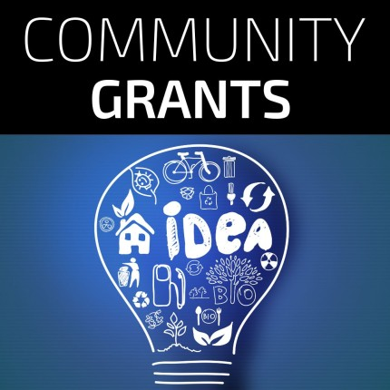
Cash-4-Cans Sorting
The aluminium can backlog at the tip is coming to an end! With one more well-supported event, this recycling initiative can transition to hosting events every two to three months. The next event is on Wednesday, May 15th, from 9:30 am to 12 pm.
Volunteers are reminded to wear long sleeves, a hat, and closed-toe footwear. Kindly RSVP by emailing
wastemanagement@flinders.tas.gov.au.

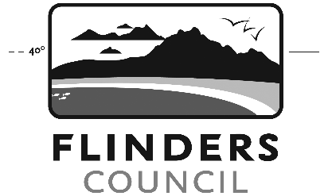
CALL FOR COMMITTEE REPRESENTATIVE
Nominations from the public are called for the position of Transport Sector Representative on the Furneaux Group Shipping Special Committee of Council.
The Committee consists of council and community representatives and exists to provide recommendations to Flinders Council on shipping matters, including port and associated infrastructure where it relates to shipping.
Nominations can be sent to:
Governance
Flinders Council
PO Box 40, Whitemark TAS 7255
Or via email to governance@flinders.tas.gov.au
The nomination period will remain open until Council receives sufficient nominations.
Rachel Summers
Chair | Furneaux Group Shipping Special Committee
POLICIES TO BE ADOPTED
Council’s Policy Manual is an important document of Council as it provides direction to Staff, Management and Councillors. Many of the policies are required by, or relate to, legislation and in most instances help manage Council’s exposure to risk.
Council resolved at the 17 April 2024 Ordinary Council Meeting to adopt the following policies:
• S-HR15 Personal Information Protection Policy, and
• S-HR14-P Fraud and Corruption Control Plan

The policies will lie on the table for public comment until 17th May 2024. They are also available to download from the Council Website www.flinders.tas.gov.au/policies and a hardcopy is available from the Council Office.

Should you wish to make comment on these policies, please do so by addressing relative correspondence to:

Warren Groves
General Manager
PO Box 40
Whitemark TAS 7255

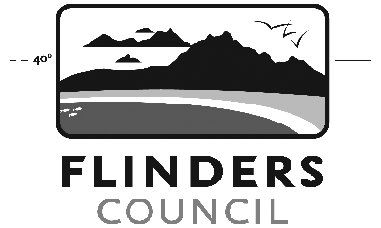
ORDINARY COUNCIL MEETING
Notice is hereby given that the next Ordinary Meeting of Flinders Council will be held at the Flinders Arts and Entertainment Centre, Whitemark on:
Wednesday 22 May 2024
commencing at 1pm.
Public Question Time will be held between 1:00 – 1:30pm. Members of the public are invited to attend.
The Agenda will be available for perusal from Friday 17 May 2024 on the Council Website www.flinders.tas.gov.au and at the Council Office.
Warren Groves
General Manager

